1. **Accessing GRS17 HFM Application via Smartview:**

Users can either save a shared connection as private connection or create a private connection directly. Find the procedures below :

* **Create a private connection directly (preferred):**

1. From the Smart View ribbon, click **Panel**.
2. From the Smart View panel, click the arrow next to Home button, and then select **Private Connections**.

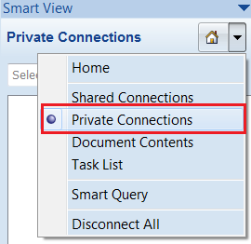

1. Click the arrow next to Go button, and then select **Create new connection**.

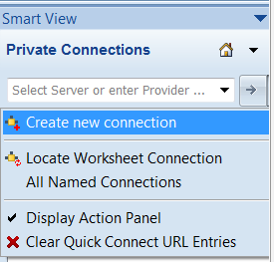

1. Select **Smart View HTTP Provider** from the prompt.

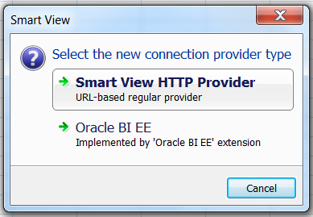

1. In the text box, enter the following URL:

<http://grsfm.capgemini.com/hfmofficeprovider/hfmofficeprovider.aspx>

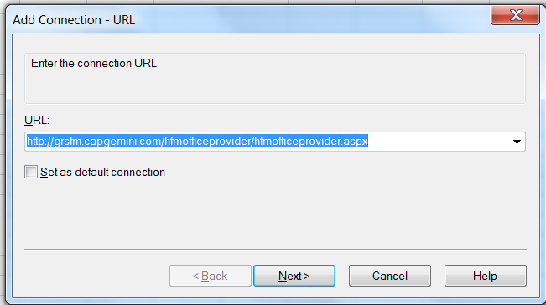

1. Click **Next**.
2. Display **Servers** then **HFMPROD** and select **GRS17**.

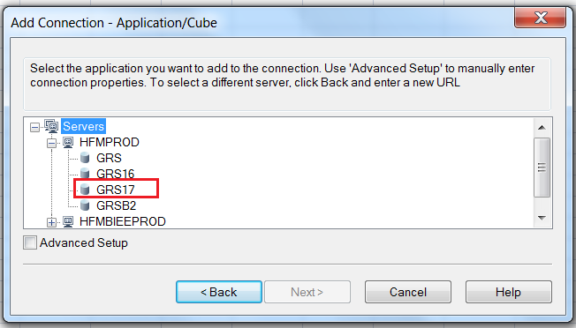

1. Click **Next**.
2. Set up the connection **name** as following: **GRS17_PROD**.

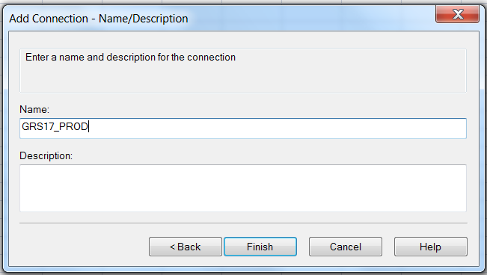

1. Click **Finish.**
2. The connection name is displayed under the Private Connections dropdown menu.Use this connection to connect **GRS17** Application.

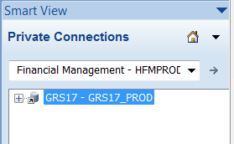

* **Save a shared connection as private connection:**

1. In Smart View ribbon, click **Options** button. The Options window is displayed.
2. In the **Advanced** section, set up the **Shared Connections URL** setting as following:

<http://grsfm.capgemini.com/workspace/SmartViewProviders>

1. Click **OK**.
2. From the **Smart View ribbon**, click **Panel**.
3. From the **Smart View panel**, click **Shared Connections**.
4. The Connect to Data Source window is displayed.
5. Enter your CORP username/password.
6. Select **Oracle® Hyperion Financial Management, Fusion Edition** in the **Select Server to proceed** picklist.
7. Expand **HFMPROD**
8. From the **Shared Connections tree list**, select **GRS17**.
9. From the **Action Panel**, select **Add to private connections**. This option is available only if the selected item is enabled for saving as a private connection.
10. From **Save as Private Connection**, set up the connection **name** as following: **GRS17_PROD.**
11. Click **OK**.
12. The connection name is displayed in the following:
    * The Shared Connections tree list, indicated as private by a small arrow.
    * The Private Connections dropdown menu.